Step 1: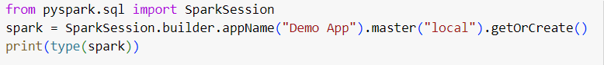

Step 2:

Step 3:



Step 4:

